# Goals of Evaluation:

Evaluation has three main goals: to assess the extent and accessibility of the system’s functionality, to assess users’ experience of the interaction, and to identify any specific problems with the system

# Evaluation through expert analysis:

## Cognitive Walkthrough:

The cognitive walkthrough is a usability evaluation method in which one or more evaluators work through a series of tasks and ask a set of questions from the perspective of the user.

The focus of the cognitive walkthrough is on understanding the system's learnability for new or infrequent users. The cognitive walkthrough was originally designed as a tool to evaluate walk-up-and-use systems like (ATMs), and interactive exhibits in museums where users would have little or no training.

In the cognitive walkthrough, the sequence of actions refers to the steps that an interface will require a user to perform in order to accomplish some known task. The evaluators then ‘step through’ that action sequence to check it for potential usability problems

Usually, the main focus of the cognitive walkthrough is to establish how easy a system is to learn. More specifically, the focus is on learning through exploration

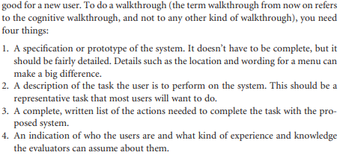

## Heuristic Evaluation:

A usability evaluation method in which one or more reviewers, preferably experts, compare a software, documentation, or hardware product to a list of design principles (commonly referred to as heuristics) and identify where the product does not follow those principles.

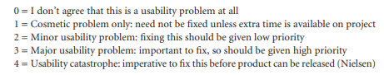

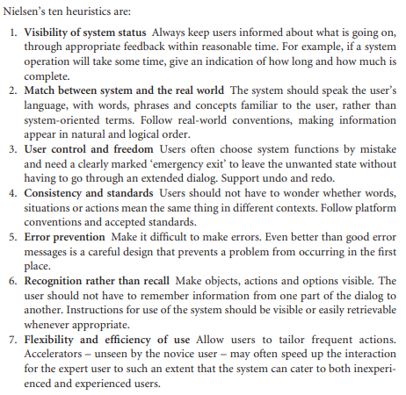

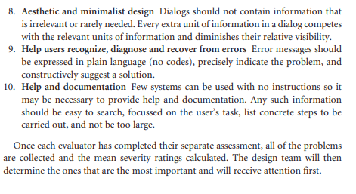

## Model Based Evaluation

## Using Previous Studies in evaluation

A final approach to expert evaluation exploits this inheritance, using previous results as evidence to support (or refute) aspects of the design. It is expensive to repeat experiments continually and an expert review of relevant literature can avoid the need to do so.

# Evaluation Through user participation:

The techniques we have considered so far concentrate on evaluating a design or system through analysis by the designer, or an expert evaluator, rather than testing with actual users. However, useful as these techniques are for filtering and refining the design, they are not a replacement for actual usability testing with the people for whom the system is intended: the users. In this section we will look at a number of different approaches to evaluation through user participation. These include empirical or experimental methods, observational methods, query techniques, and methods that use physiological monitoring, such as eye tracking and measures of heart rate and skin conductance.

## Styles of evaluation

### Laboratory studies

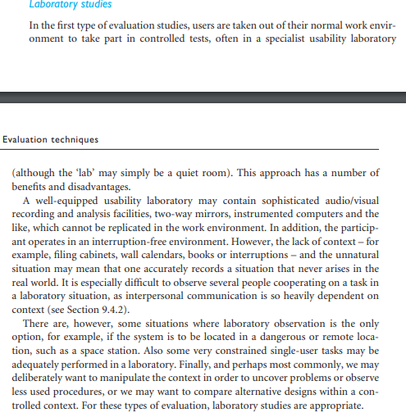

### Field Studies

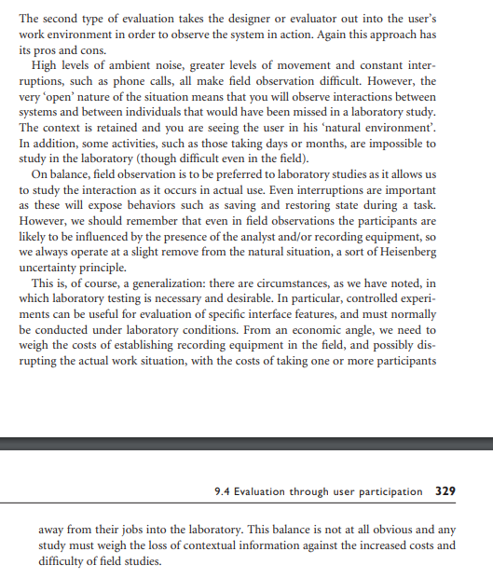

## Empirical Methods: Experimental Evaluation

One of the most powerful methods of evaluating a design or an aspect of a design is to use a controlled experiment

### Participants

### Variables

Dependent

Independent

### Hypothesis

### Experimental Design

### Statistical Measures

### Evaluating Icon design

### Studies of groups of users

## Observational Techniques

### Think aloud and cooperative evaluation

### Protocol Analysis

* + - 1. Paper and Pencil
      2. Audio Recording
      3. Video Recording
      4. Computer Logging
      5. User Notebooks

### Automatic Protocol Analysis Tools

### Post-Task Walkthroughs

## Query techniques

### Interviews

### Questionnaires

## Evaluate through monitoring physiological responses

### Physiological Measurements

# Choosing an Evaluation Methods

## Factors distinguishing evaluation techniques

### Design vs. Implementation

### Laboratory vs. Field Studies

### Subjective vs. Objective

### Qualitative vs. Quantitative

### Information provided

### Immediacy of response

### Intrusiveness

### Resources